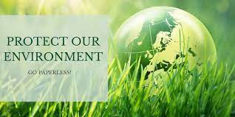

**What should we do to help our environment?**

* Recycled: cardboard, glass, plastic, oil and aluminium cans. We should put it in coloured bins.

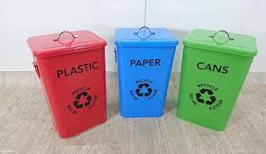

* Turn off lights, TVs, computer etc..., when we do not need them.

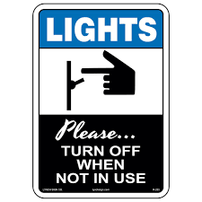

* Walk or ride our bike instead of taking a car everywhere.

.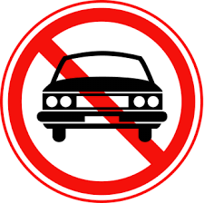

* Take short showers instead of baths.

.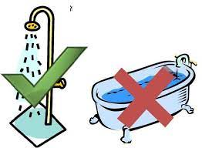

* Plant more trees.

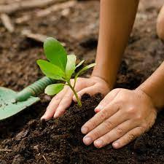

* use solar energy more.



**What shouldn´t we do to help our environment?**

* Waste water and paper

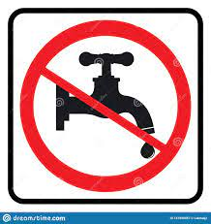

* Cut down trees.

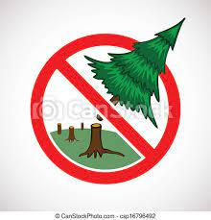

* Throw rubbish in the wild

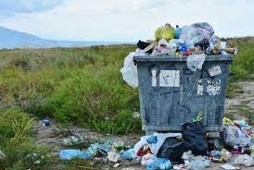

* Use coal in houses. It pollutes air very much.

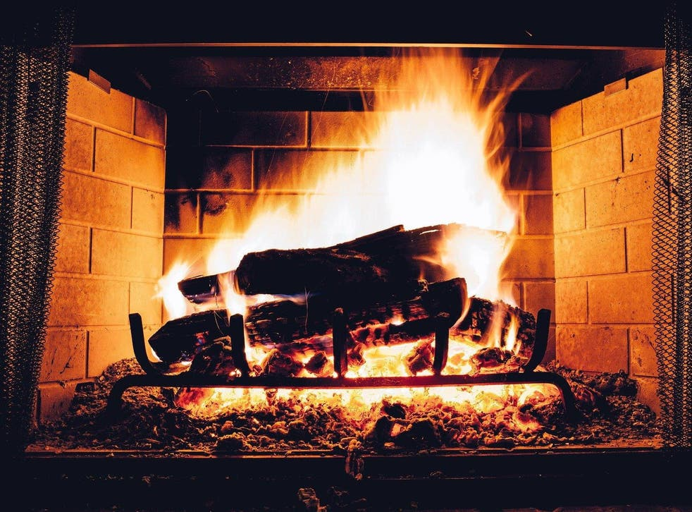

* Hunt animals.



We should protect our planet. It's a place where we live so we should treat it nicely. Do not let that become a huge dumping ground. Unfortunately, our planet is in danger! Its major problems are global warming, deforestations and water shortages. These cause a hard life for over a half of the people on this planet and the death of lots of plants and animals.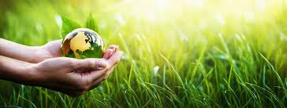

A lot of animals for example penguins, polar bear etc... are losing their habitats, because of the melting of the ice caps. The most important cause is global warming.

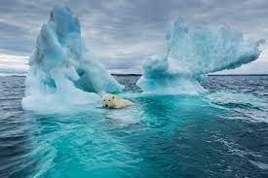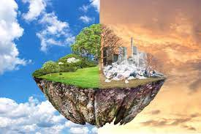

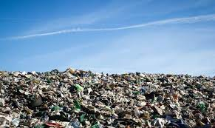Plastics are made from fossil fuels. Once they are used, most plastic bags go into landfill or rubbish tips. Each year more and more plastic bags are ending up littering the environment. Once they become litter, plastic bags find their way into our waterways, parks, beaches and streets. And, if they are burned, they infuse the air with toxic fumes. Plastics are more and more used, and they are more and more in the sea where live sea animals and plastics kill these cute animals. This is horrible.



